**Applications of Derivative**

**Lecturer: Anurag Dutta**

**Date of Conduct: November 25, 2021**

E-Mail: [1anuragdutta@gmail.com](mailto:1anuragdutta@gmail.com)

**1 Introduction**

The term, $\frac{dy}{dx}$ represents the derivative of a function, $y = φ(x)$ with respect to the variable ‘x’.

Derivatives has a lot of application, majorly in the field of engineering. In today’s lecture, we will cover the topics of

* Tangent and Normal
* Maxima and Minima

**2 Theory**

What is tangent? Basically, it’s a straight line that touches a curve or a curved surface at a point and can be further extrapolated (that means it can be further extended). Now, the next question arises, what is normal? It a line that is perpendicular to the tangent at the point of contact. So basically, what we are trying to say, is that the normal and the tangent are perpendicular to each other.

Now, we will be talking about the Maxima and Minima.

Maxima is simply the maximum value that can be attained by a curve $y = f(x)$. So, what will be the maxima of $y = \sin{x}$? Yes, you are right, its +1.

Minima is simply the minimum value that can be attained by a curve $y = f(x)$. So, what will be the minima of $y = \sin{x}$? Yes, you are right its – 1.

**3 Mathematical Accession (Approach)**

Firstly, we would be discussing the mathematical approach to find the tangent and normal.

Suppose, we are given a curve $y = φ(x)$, then the slope of the tangent to the curve at the point $(α,β)$ that lies on the curve $y =φ(x)$ is found by putting the value of

$$x = α and y = β$$

on the first derivative of the function $y = φ(x)$.

For Example, to find the equation of tangent to the curve $y = e^{-ωx}+e^{-ωy}$, at the point $(γ,δ)$ where $ω, γ,δ$ are constants, firstly we will have to find the derivative of $y = φ(x)$.

$$\frac{dy}{dx} = e^{-ωx}×\frac{d\left(-ωx\right)}{dx} + e^{-ωy}×\frac{d\left(-ωy\right)}{dx}$$

$$\frac{dy}{dx} = -ω×e^{-ωx} -ω{×e}^{-ωy}×\frac{dy}{dx}$$

$$\frac{dy}{dx}(1 +ω{×e}^{-ωy}) = -ω×e^{-ωx}$$

$$\frac{dy}{dx} = \frac{-ω×e^{-ωx}}{(1 +ω{×e}^{-ωy})}$$

Putting x = $γ$ and y = $δ$, we get the slope of the tangent at the point $(γ,δ)$ and that is $\frac{-ω×e^{-ωγ}}{(1 +ω{×e}^{-ωδ})}$.

Now, we know, the one-point (x1, y1) form of a straight line is

$$(y-y_{1}) = m(x-x_{1})$$

Using that, we get

$$(y-δ) = \frac{-ω×e^{-ωγ}}{(1 +ω{×e}^{-ωδ})}×(x-γ)$$

which is the equation of the tangent.

Now, to find slope of normal, we can simply take the multiplicative inverse of the slope of tangent followed by the additive inverse. i.e., if the slope of tangent is $\frac{dy}{dx}$, then the slope of the normal will be

$$\frac{-1}{\frac{dy}{dx}} = -\frac{dx}{dy}$$

Now, your task will be to find the equation of normal to the curve $y = e^{-ωx}+e^{-ωy}$, at the point $(γ,δ)$ where $ω, γ,δ$ are constants.

Now, we would be discussing the mathematical approach to find the maxima and minima.

Suppose, we are given a curve $y = φ(x)$, and we need to find the maxima or minima of that curve. So, what we are going to do?

Firstly, we will find the first derivative of that curve and will make that equal to Zero. The value of x for which $φ'(x) = \frac{d(φ(x))}{dx}$ equals zero, are known as critical points. Now, after we are done with the first derivative, we will find the second derivative. i.e., $φ''(x) = \frac{d^{2}(φ(x))}{{(dx)}^{2}}$ and put the critical values of x in the expression obtained after 2’nd Derivative. On substituting that, if the value of

* $φ''(x) > 0$, then the Critical value ‘x’ will be the point of minima.
* $φ''(x) < 0$, then the Critical value ‘x’ will be the point of maxima.
* $φ''(x) = 0$, then the Critical value ‘x’ will be the point of inflexion. In that case, we have to switch to higher derivatives like $φ'''(x), φ''''(x), ...$

After that, when we put the value of ‘x’ in the equation $φ(x)$ we will get the maxima or minima accordingly.

For Example, to find the maxima and minima of the curve $y = e^{-ωx}$, $ω>0$ is a constant, firstly we will have to find the first derivative of $y = φ(x)$.

$$φ'(x) = -ωe^{-ωx}$$

*Putting $φ'(x) = 0$, we get*

$e^{-ωx} =$ 0

*Taking loge() on both sides*

$$\log_{e}{e^{-ωx}} = \log_{e}{0} = ∞$$

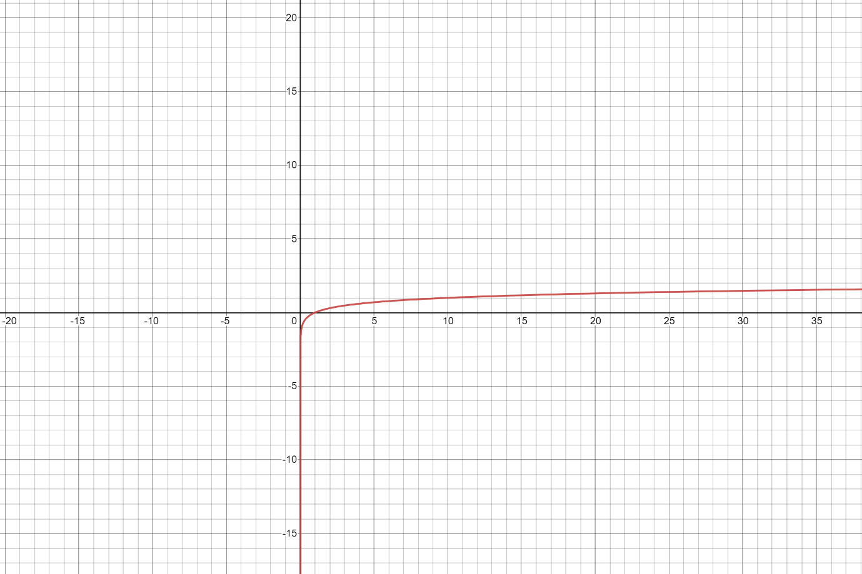

$$⇒\log_{e}{e^{-ωx}} = ∞$$

$$⇒-ωx = ∞$$

$⇒x = ∞$, which is the *Critical Point*

Now, it’s to find the 2’nd derivative of $y = φ(x)$

So, we will *derivate the first derivative again.*

$$φ''(x) = \frac{d}{dx}(-ωe^{-ωx}) = -ω×-ω×e^{-ωx} = ω^{2}×e^{-ωx}$$

Putting the Critical Point in the $φ''(x)$, we get the value of it to be zero. So, it’s the point of inflexion.

**4 References**

* NCERT Class 12 Mathematics Textbook (Part 1).
* Differential and Integral Calculus by N.Piskunov.
* Calculus and Analytic Geometry by Thomas and Finney